Sallisaw 2014 Marching Shirt
Please return order form and money by Thursday September 5th to receive in time for first contest
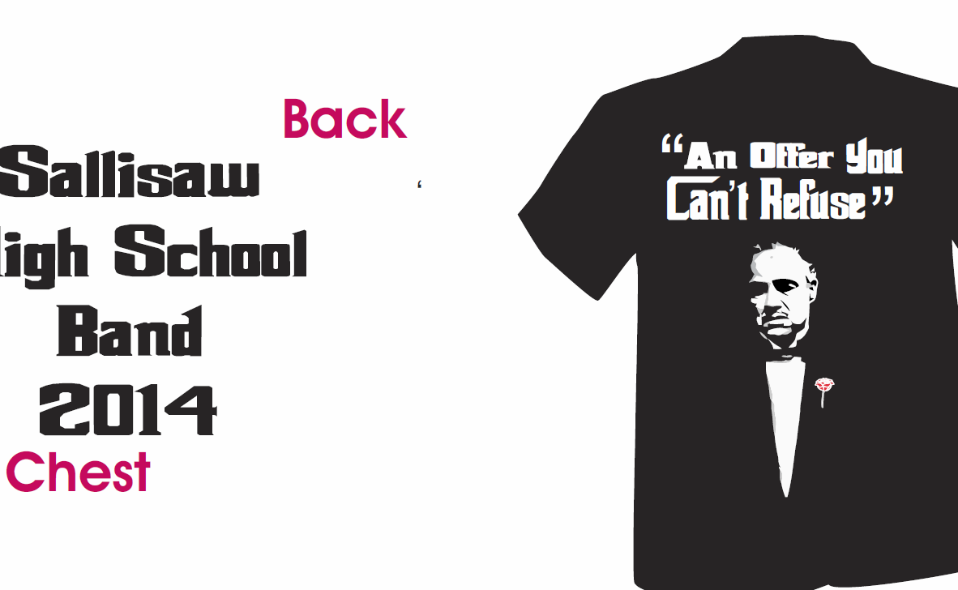

Cost is $10 per shirt
Name____________________
Size_____________________
Total Amount Enclosed ____________________

